**Regular Interval vs Psychological factors**

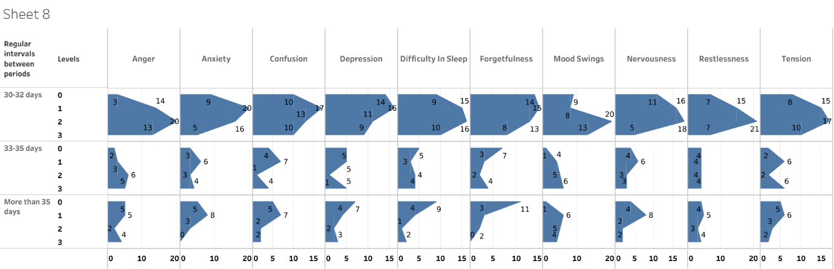

For 30-32 days, there were occasional mild and moderate psychological problems. For more than 35 days, it was non-existent and mild. It was a mixture of all the levels for 30 to 35 days.

**Regular Interval vs Physiological factors**

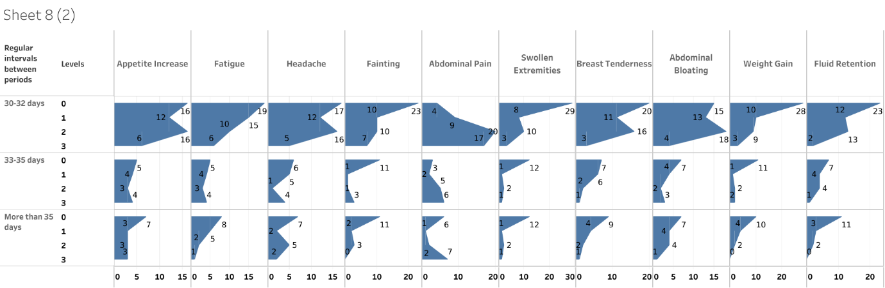

Every interval had primarily moderate abdominal pain. The other physiological symptoms were largely absent or mild for all of the intervals.

**Regular Interval vs Heaviness**

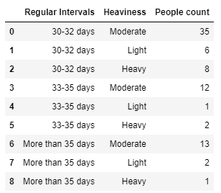

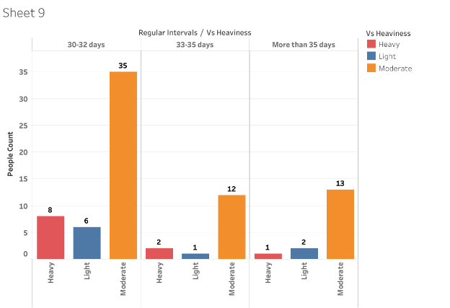

Based on the data collected from the above Figure, it can be concluded that every period mostly encountered moderate flow.

**Puberty Stages vs Psychological factors**

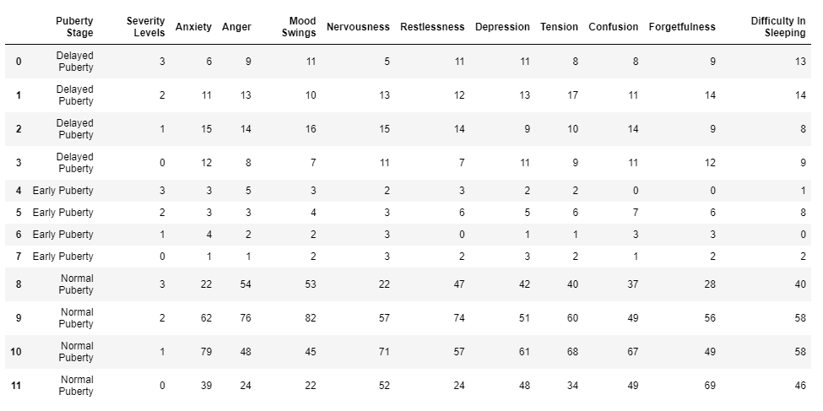

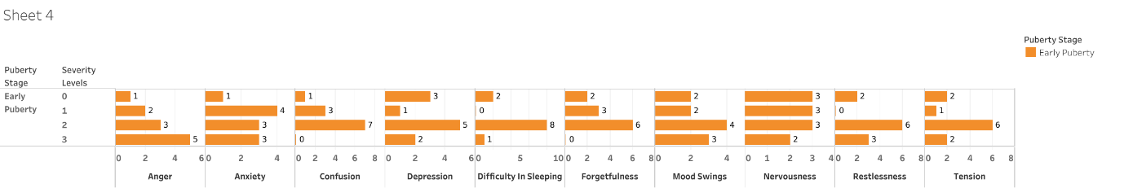

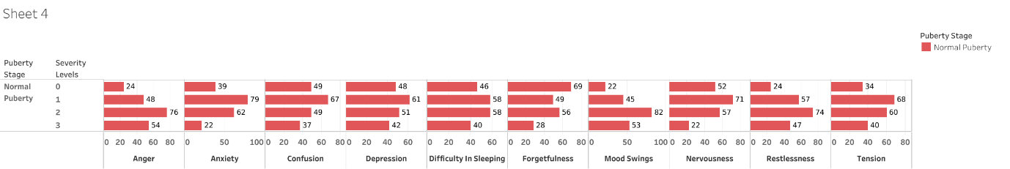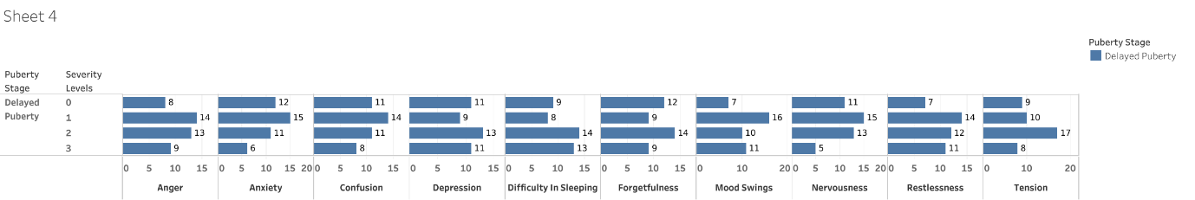

Early puberty has moderate symptoms, normal puberty has mild to moderate symptoms, and delayed puberty has severe to moderate symptoms.

**Puberty Stages vs** **Physiological factors**

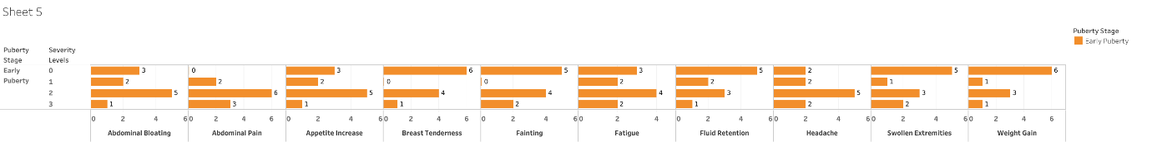

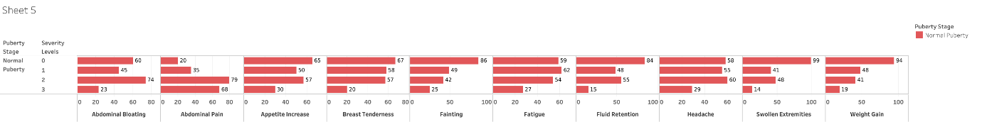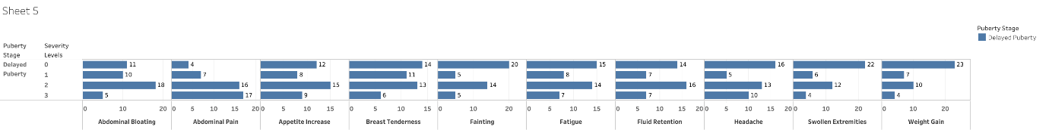

When compared to normal and delayed puberty, early puberty has more physiological signs.

**Puberty Stages vs Heaviness**

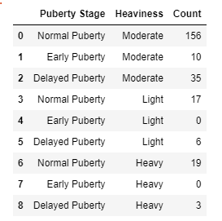

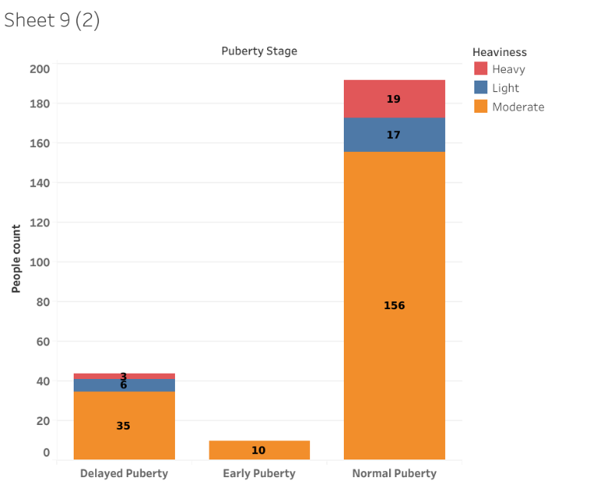

The information in the Figure hints that normal and delayed puberty have a mix of all types of flow, whereas early puberty has a moderate flow.

**Heaviness vs** **Psychological factors**

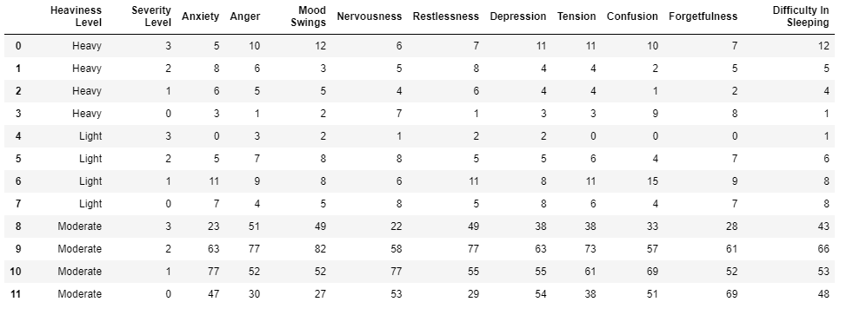

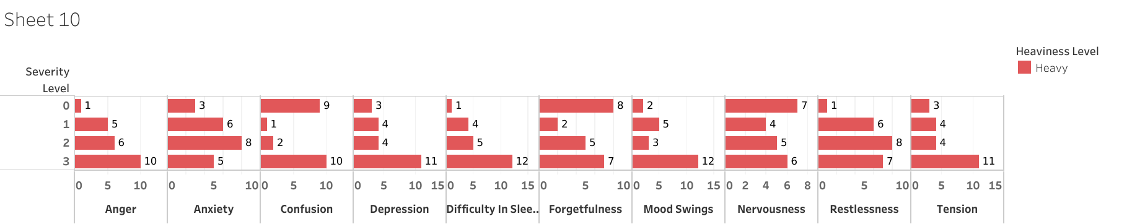

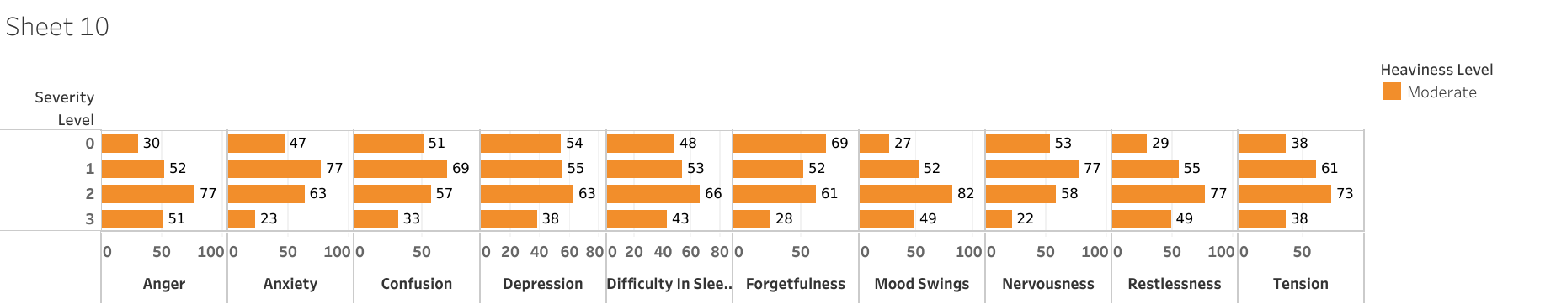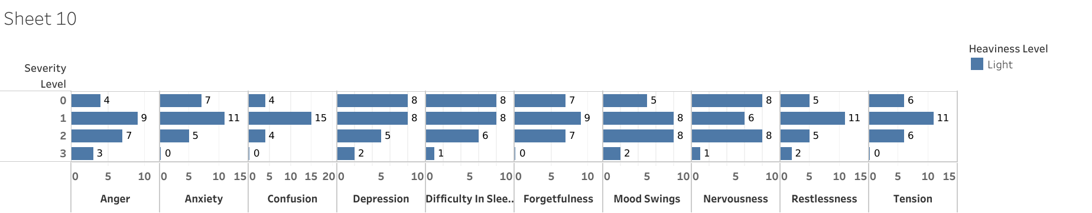

Psychological symptoms were severe in the case of heavy flow, mild to moderate in the case of moderate flow, and non-existent or mild in the case of light flow.

**Heaviness vs** **Physiological factors**

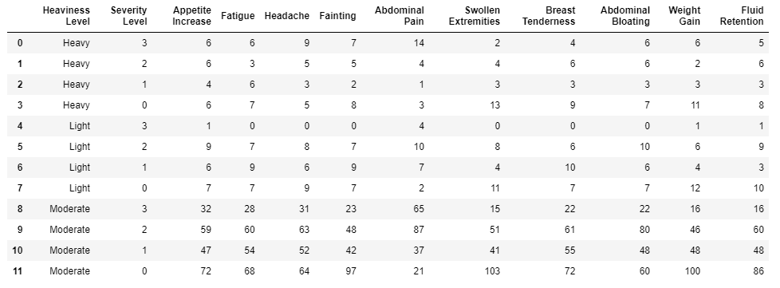

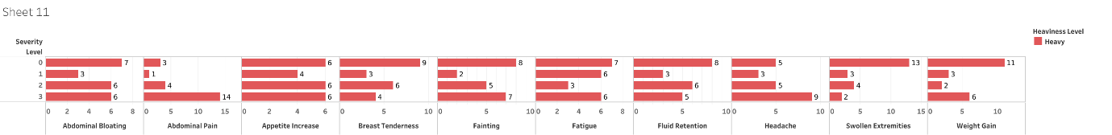

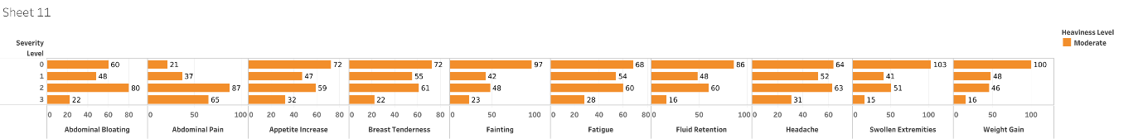

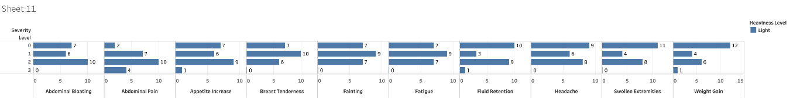

Physiological symptoms were severe in the case of heavy flow, mild to moderate in the case of moderate and light flow.

**Duration** **vs Psychological factors**

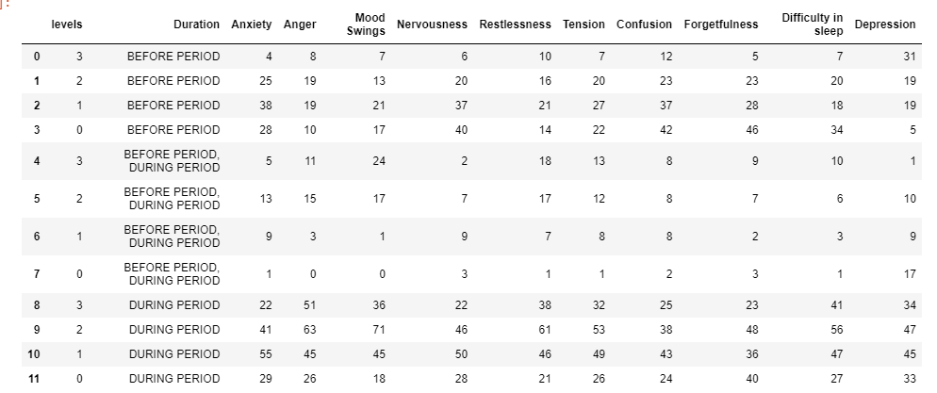

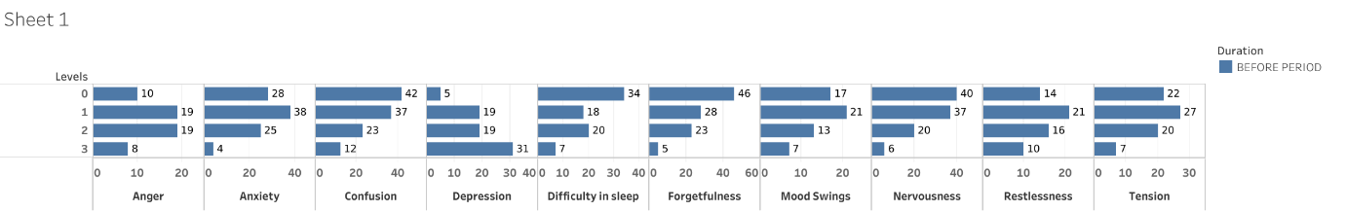

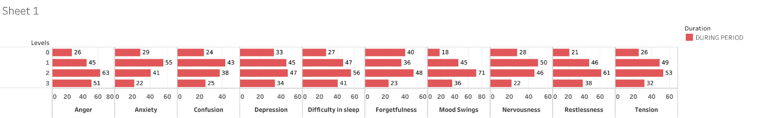

From the above interpretation, it can be concluded that, the psychological symptoms were mild before periods and high during periods.

**Duration** **vs** **Physiological factors**

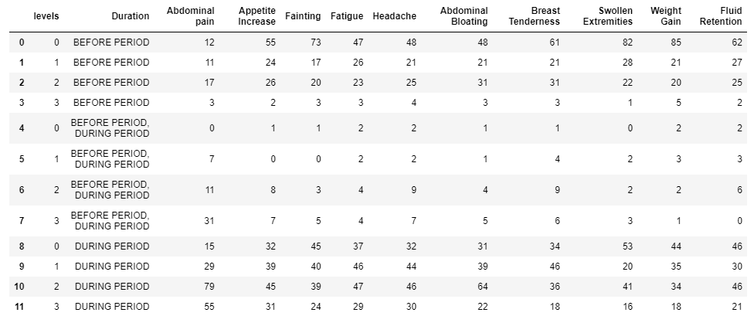

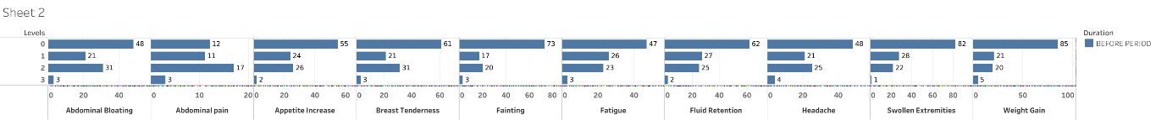

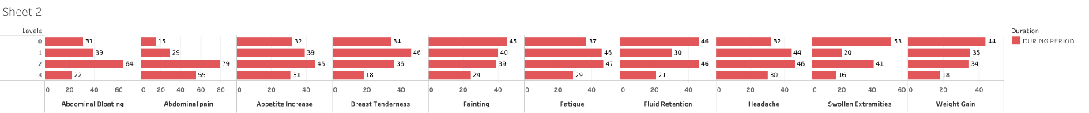

From the above interpretation, it can be concluded that, the symptoms were physiological mild before periods and high during periods.